S.VIGNESH
192512378

27. Prolog Program for Fruit and Its Color Using Backtracking
Aim:
To write and execute a Prolog program to represent fruits and their colors and retrieve the possible fruits and colors using backtracking.
Algorithm:
- Start the program.
- Define facts containing different fruits and their colors.
- Create a rule to find the color of a fruit.
- Create a rule to find fruits having a particular color.
- Enter a query for a fruit or color.
- Prolog searches the facts and returns the matching result.
- Press ; to activate backtracking and find the next possible answer.
- Continue until all matching answers are displayed.
- Stop the program.

PROGRAM:
% Fruit and Color Database

fruit(apple, red).
fruit(banana, yellow).
fruit(mango, yellow).
fruit(grapes, green).
fruit(orange, orange).
fruit(guava, green).
fruit(strawberry, red).

% Find the color of a fruit
color(Fruit, Color) :-
fruit(Fruit, Color).
INPUT:
?- color(apple, Color).
OUTPUT:
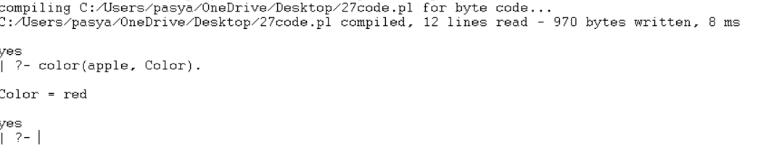

RESULT:
Thus, the Prolog program for finding fruits and their colors using backtracking was successfully implemented and executed, and all matching fruits and colors were obtained successfully.

